**Mood board**

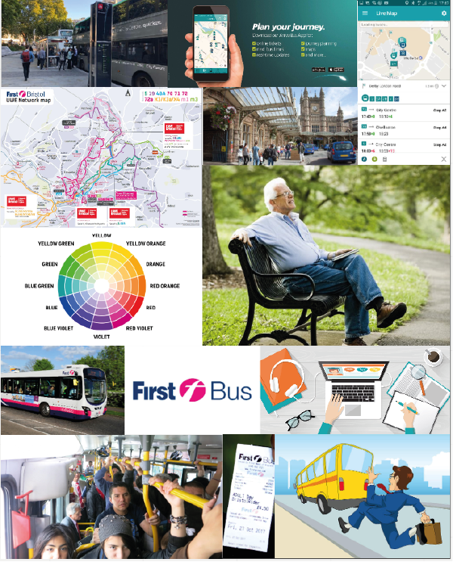

**Pop-up on front page**

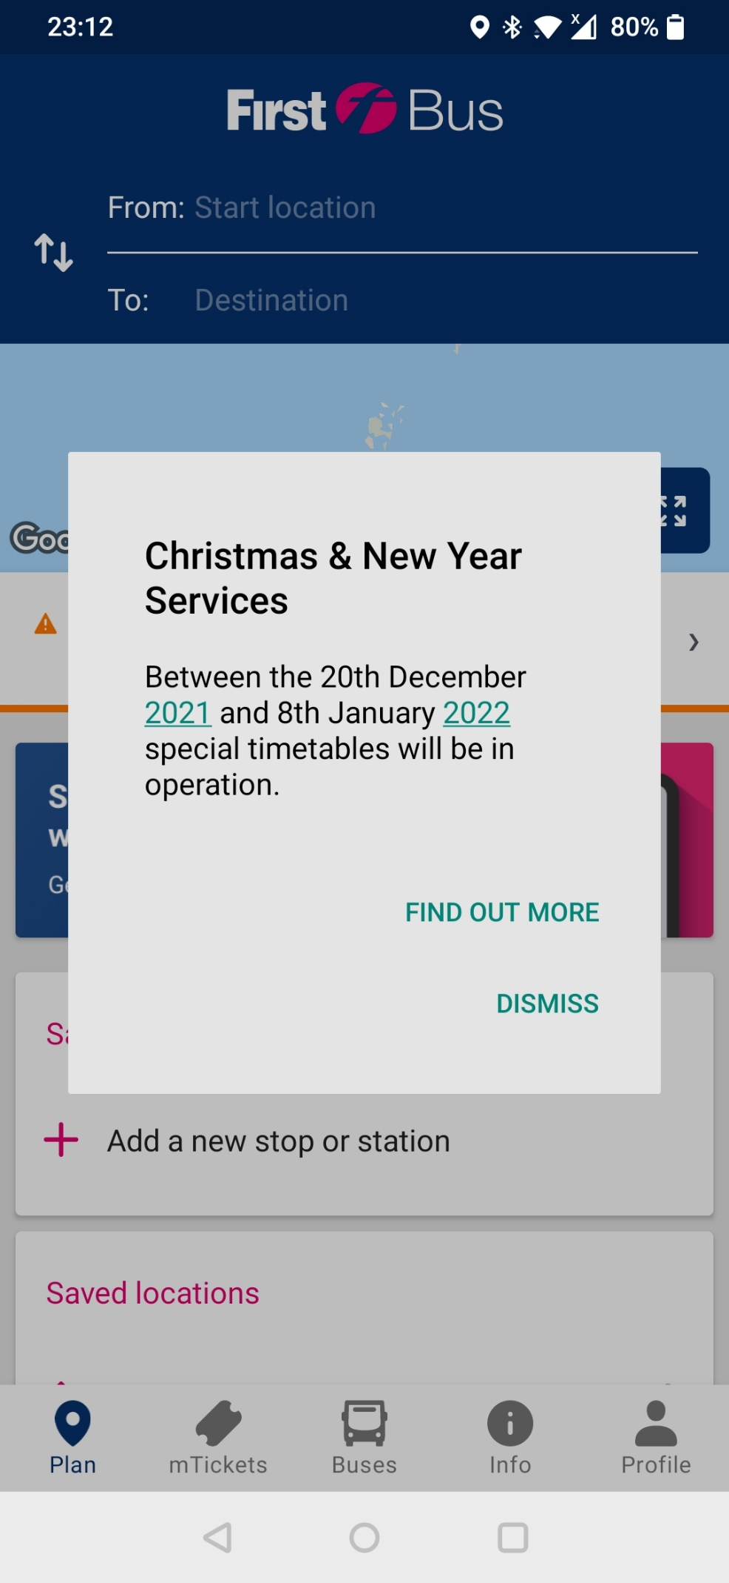

Here the user is given two options.

This pop-up information could potentially affect that user, or this information could be useless to a user so they can easily dismiss the information.

In addition to this, the user cannot remove the pop-up without clicking dismiss. This is significant because a user may be in a rush and potentially miss the information. This stops any accidental miss clicking from occurring – useful to all.



Occasionally, first bus app will have pop-up information when you first load up the app - this is useful for all. For example, they recently had a pop-up reminding people to wear masks on public transport.

The layout of the information is clear and easy to read due to the hierarchy. This is good design and important information is highlighted or in bold.



**Plan page**

Get the latest news of travel. If clicked this takes the user to a website stating all the changes. For a retired person or someone who may not be familiar with technology, suddenly changing screen could be quite daunting and they could easily lose track of where they were.



The map is not the most responsive and is hard to follow for anyone of any age. It is slow to tell you what angle you are facing. Not so clear as to where your start and end point is.

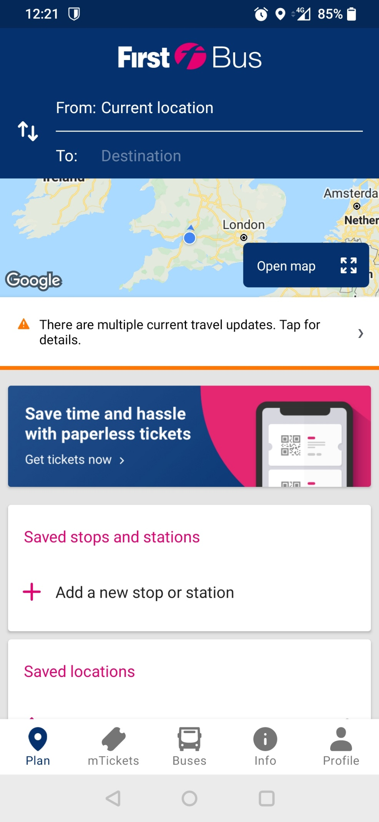

The app has a consistent colour scheme. This could make users have a more pleasant experience as there is little change in appearance.



First bus logo is apparent on the front page. This makes the user aware of which company they are using.



This is clear for most people; it can get confusing when location is not turned on as it will show multiple results.



Saved stops makes it easy for users who are frequent bus users pick their destination quickly. This can be effective for anyone any age as it enables people to quickly determine their destination without going through the destination bar every time.

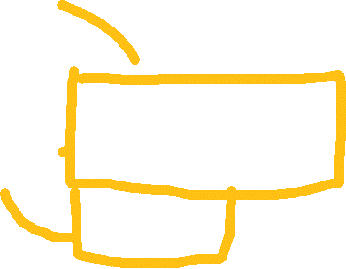

**Route details**

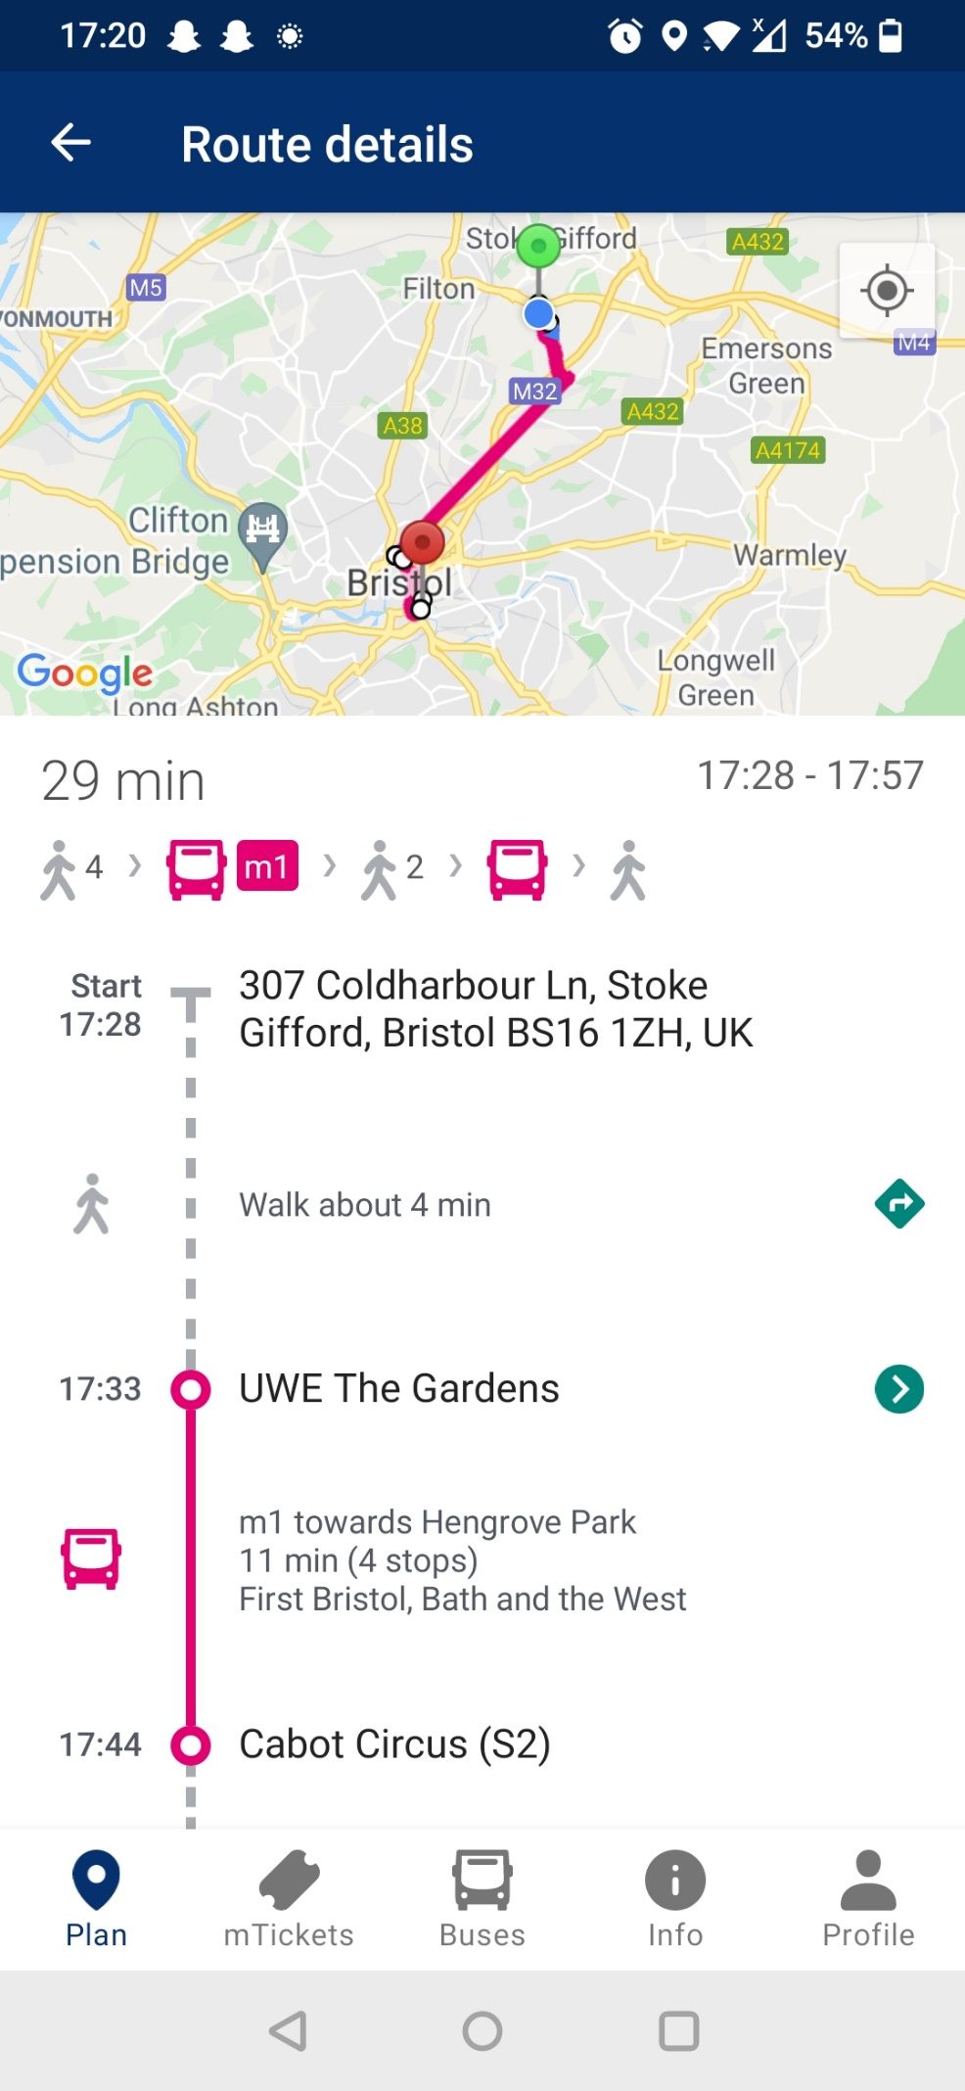



Imagery is very useful as it helps people identify which transport method will be occurring at what given time.



Predicted time helps plan a journey, however the walking speed is the average walking speed. This could be higher or lower based on a variety of reasons. Some users may not consider this and end up late to the bus stop.

There are zero notifications or information to let people know whether the bus is late or early. With a service like this it is imperative to know ETA.

For example, on the arriva bus app it tells users predicted ETA and will even state whether it is on time.

Clear outline of time of travel and the requirements of travel.

However, the bus needed to be taken may not be as obvious. One is labelled while the other is not.



Map is not clear and rather slow on response. A user would be better off looking up the stops name on the google maps app or maps online.

The colouring of start and end is not obvious, a colour code could potentially help.



**Navigation bar**





The navigation bar is confusing to all but from the perspective of a retired person it could be quite intimidating to look at. The title “Plan” is not very direct and has many connotations. It is slightly grounded with the location symbol, however not all is clear. “Buses” would seem like a more suitable place to put the plan icon and information.

“mTickets” is slightly more self-explanatory with it being where your tickets are stored. Although the “m” at the beginning of it could possibly cause confusion with users. However, the image of the ticket reiterates the idea that your digital tickets will be here. This could potentially be confusing to a retired person who may not be the most comfortable with technology. While you can still pay for tickets on the bus, this could potentially lead to someone overthinking and believing that tickets are only available via the app.

“Buses” is slightly confusing and misleading, since you start off on the “Plan” page which, to many users, contains all the information you would assume to be under “Buses”.

“Info” has the universal info image and to many it is obvious what the “Info” page entails.

“Profile” may not seem so obvious to a retired person; this would be common to many users from the use of social media. However, to a retired person this could possibly be a grey area in which they could guess what would be here, although, they may not seem confident in understanding it.

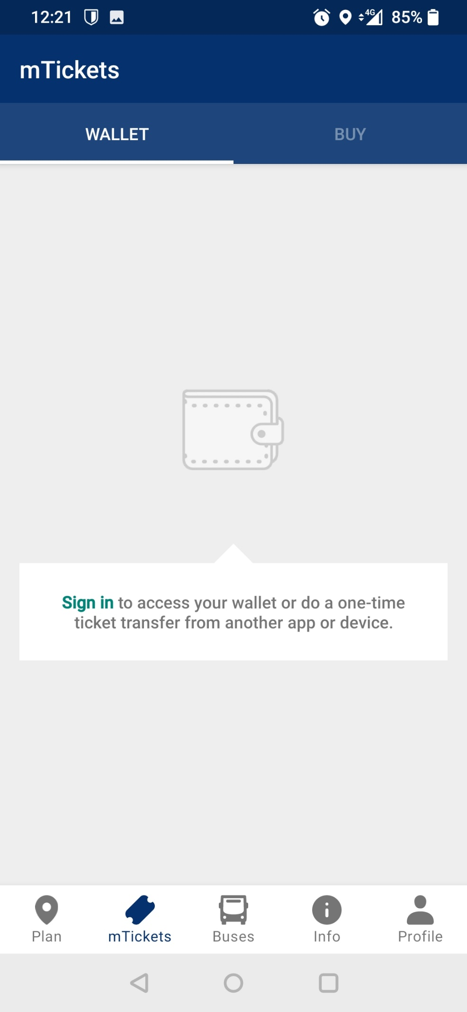

For those who may not be a consistent user of the first bus app there is a recommendation to sign in/sign up so you can access tickets across multiple devices. This is significant as a retired person may not understand the method to purchase a ticket via the app. This enables a relative or someone close to set up an account and purchase one for them. This lets the retired person have the ‘simple’ job of opening the wallet for their ticket, giving them access to the bus service.



The icon of the wallet indicates to the user that this is where you store your items, a ticket in this case. This is good use of imagery as it easy to depict for anyone the connotations the wallet has.



Two options on this page:

Wallet – where you store your tickets.

Buy – where you purchase your tickets.



Alignment of the title has changed – this could be uncomfortable for a user as the consistency you were shown on the first page (plan) has changed.

**mTickets Wallet**

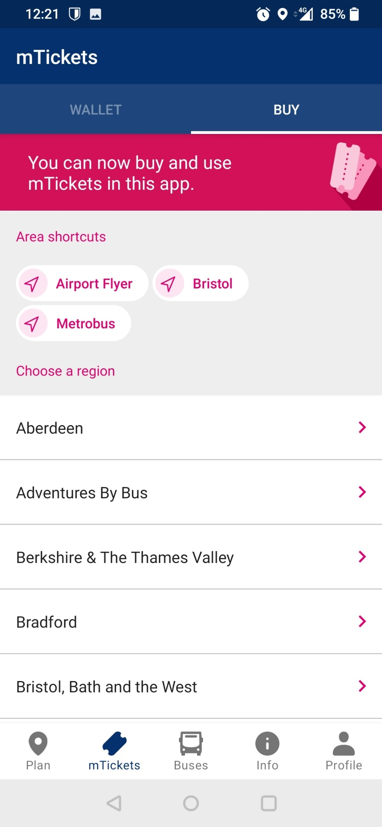



Here the user is left to pick their region they will be travelling in.



The option of the virtual ticket is new instalment and could potentially be confusing to many, especially a retired person who may struggle with technology.

At first glance this page has a lot going on and is very intimidating. This reinforces my point about a relative or someone close to the retired person purchasing the ticket for them.

**mTickets Buy**

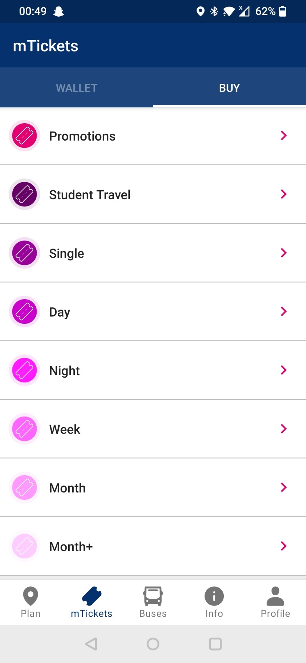

This page contains all the ticket options available for purchase.

This has a few confusing options such as “Day” and “Night” as well as “Promotions”.

The “Day” and “Night” options are not explained on the app. This could confuse many users especially a retired person or a first-time user.

This is the next page after picking your region – in this case I picked Bristol.

**mTickets Buy – ticket options**



The monochromatic colour scheme is soothing to the eye and can make the stressful amount of ticket options a little less daunting. Especially with a light colour such as pink.



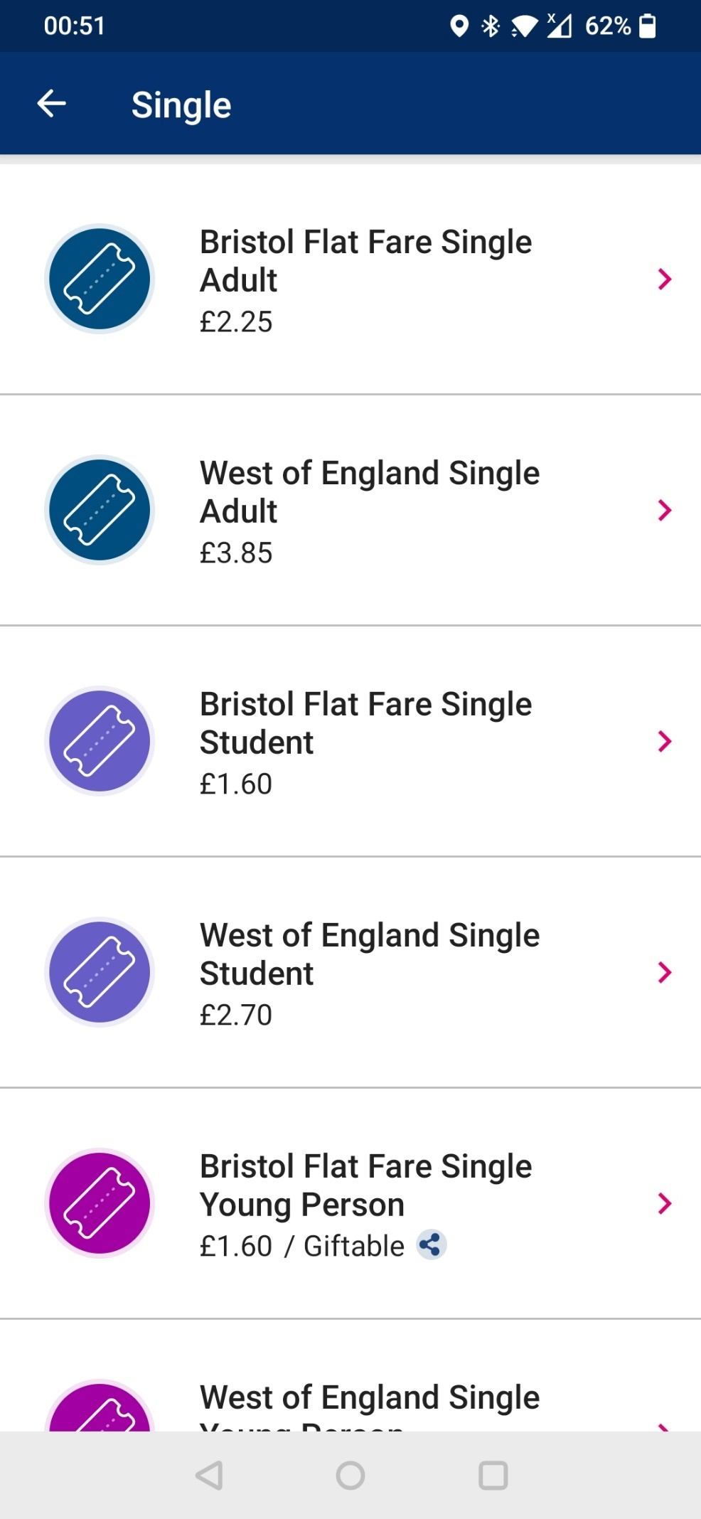



Similarly named tickets can cause/lead to complications in understanding of what exactly you are purchasing. Many buses are strict on age group tickets, and this could result in not being allowed on or having to purchase another ticket.



The ability to ‘gift’ a ticket is a convenient tool however it could also confuse users into possibly thinking this option is available for all tickets.



Multiple options can be quite unnerving as you want to buy the correct ticket as well as taking into consideration the most cost effective. To any user this is a confusing/complicated process, more so for a retired person.

Colour coordinated tickets – this makes it easier for a more experienced user. To a retired person or a first-time user this has very little significance to them.



The option I chose as an example. Similar to bread crumb navigation.

**mTickets Buy – purchasing options**

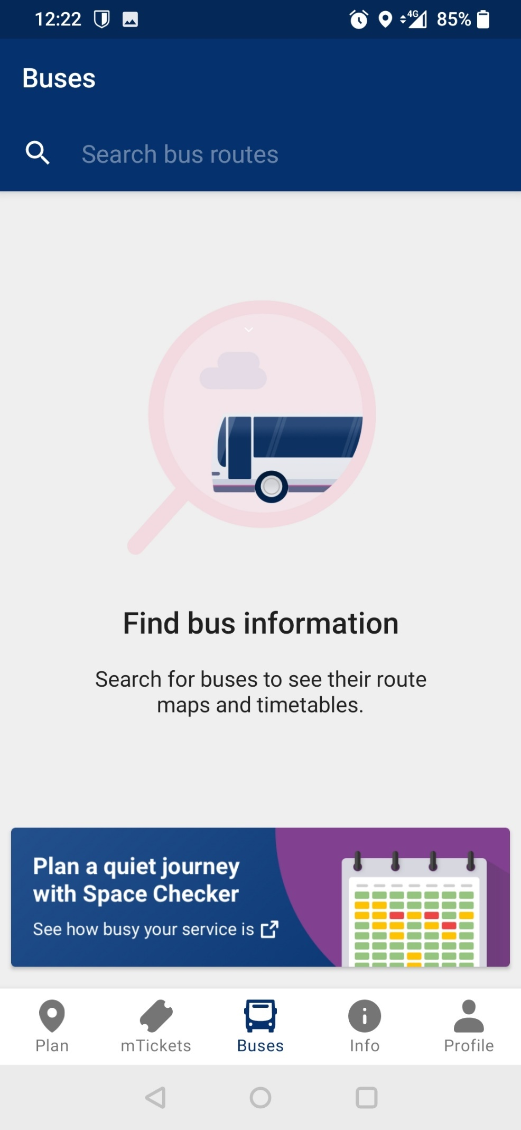



The advert at the bottom of the page could potentially confuse audiences into thinking this is another part of the app. However, for an experienced mobile user they will recognise the icon that states a new tab will be opened.



The image implies looking for something – this can be seen through the use of the magnifying glass on the bus. This helps identify the goal of this page and allows an audience at first glance to interpret the use of this specific page.

This is then reinforced with the use of text. The hierarchy of the text as well as font size/boldness enables an audience to have an easy time reading and understanding the information.

The caption grounds the image and directly tells the audience the use of the page. In addition to the caption, there is a body of text which presents more information and gives the significant specific details of the page.



The wording of this page is quite similar to the “Plan” page and could lead to confusion. Especially when they have overlapping information. Although, this page is more specific in its search.

**Buses page**

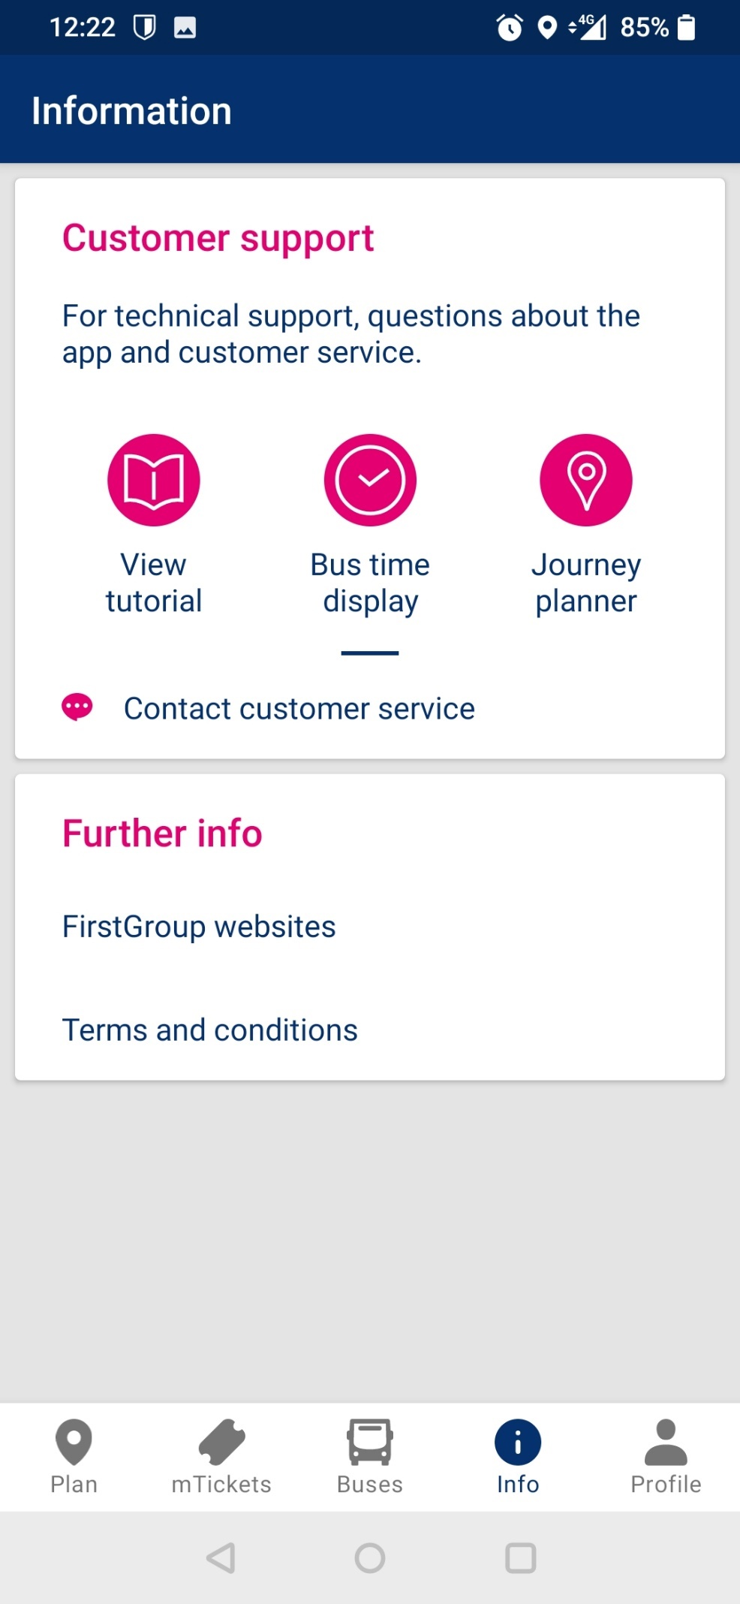

**Info page**

Layout is very clear with a consistent colour scheme that represents the first bus app – pink, blue and white.

The page being put into segments via a break makes it clear to an audience that these are separate ‘places’.

Images for the caption that follow may not be clear to some users and some images could be misleading or uninformative. For example, the image for “Bus time display” does not imply its purpose.



Not clear to a user what kind of customer service experience they will receive. The user must assume it will be done via messages due to the message symbol next to “contact customer service” to a retired person this may not be there most comfortable way of communicating and they could perhaps prefer a phone call as typing may not the easiest method of communication to them.



Link to a website as this may be an easier method of support for some users.



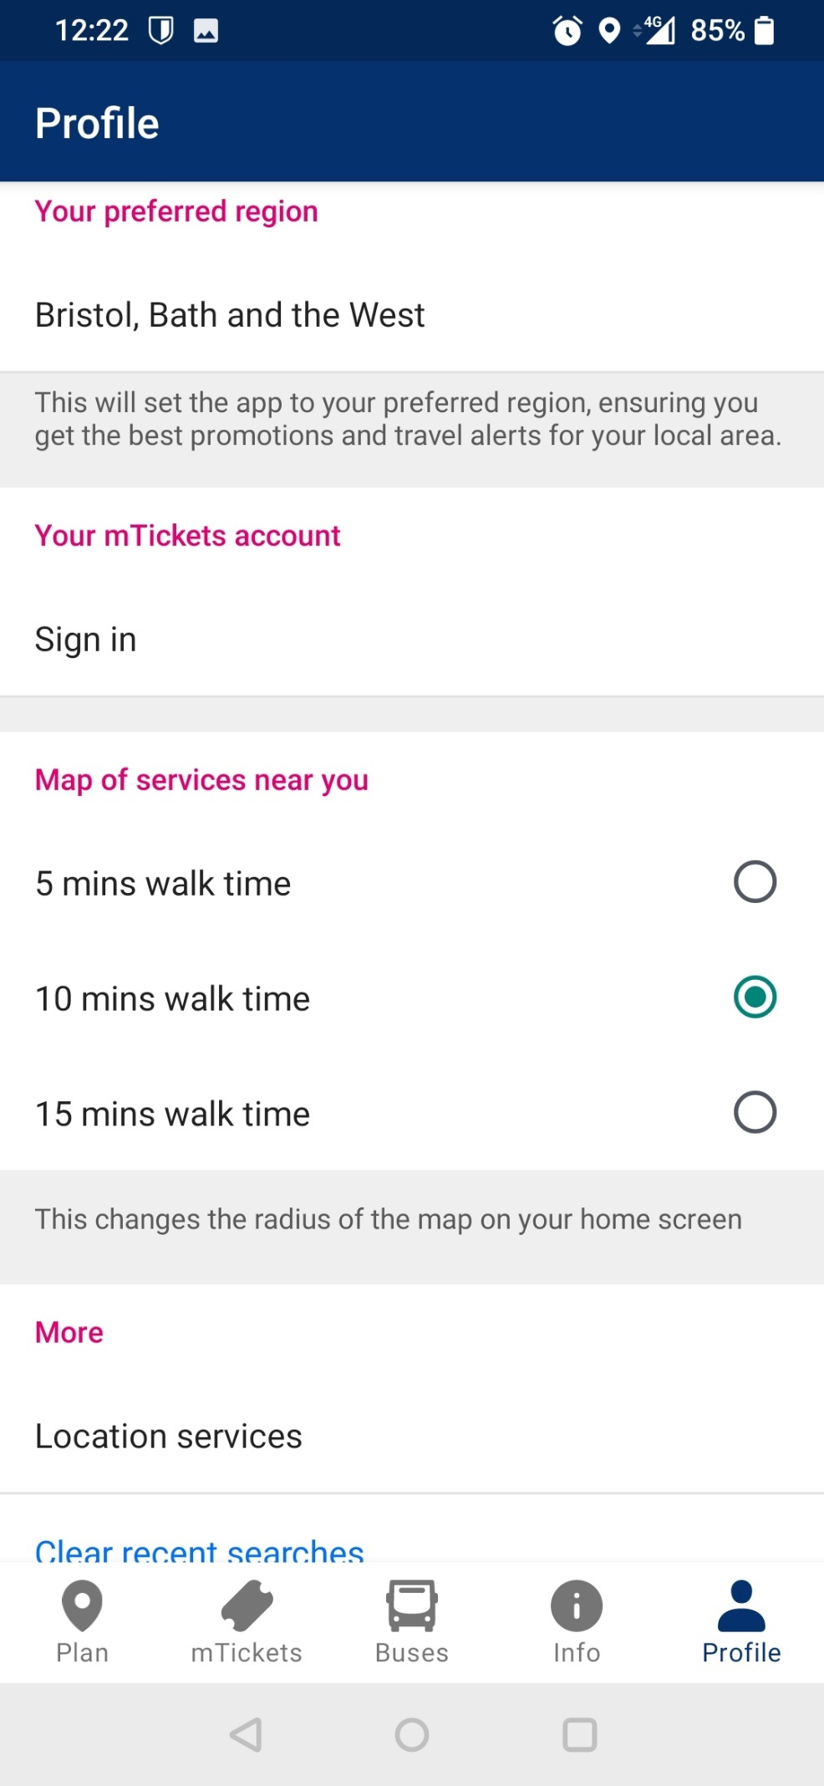



This tool can be useful for retired people as it helps home in on services closer by. The significance of narrowing down on services is the fact it helps reduce potential strain on the retired persons body if they were to walk to one fifteen minutes away instead of the one five minutes away.



Clear up some of your searches so it makes it easier to manage where you want to go. This can be useful for those who travel a lot.



This allows the app to focus in on your area and make easier/specific transport more accessible.

**Profile page**

**User Journey Templates**

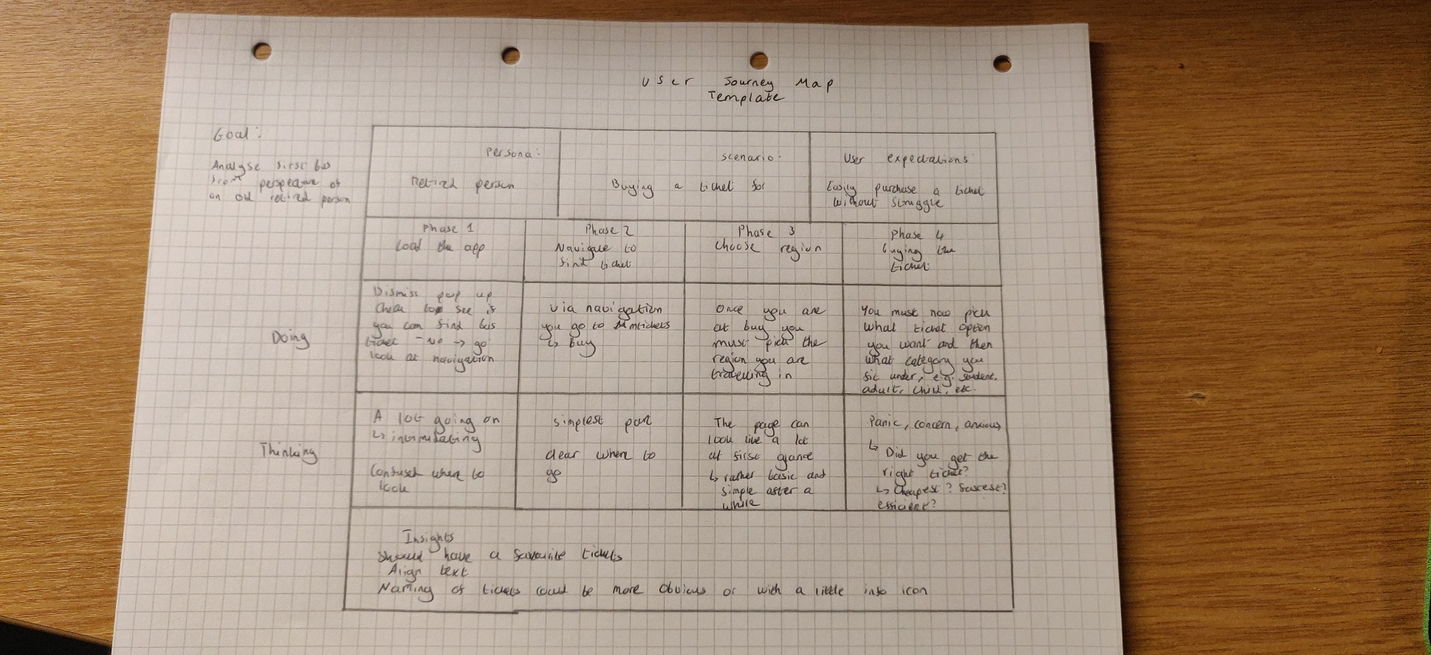

User Journey template – Buying a ticket on the app

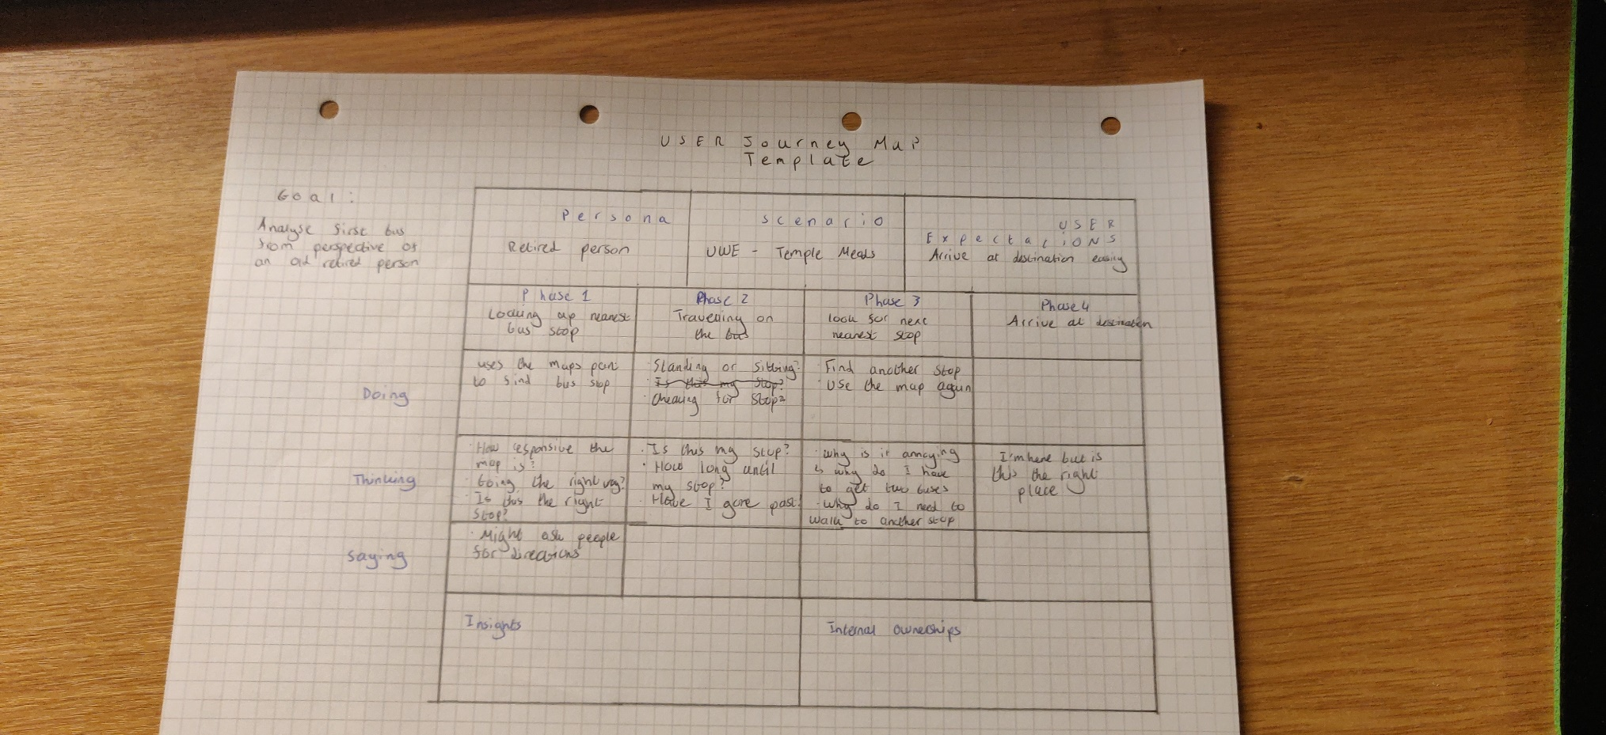

User Journey template – Travelling from UWE to Bristol Temple Meads

**User Journey**

**USER JOURNEY MAP** *Buy a ticket using first bus app & travel via first bus app*

**Expectations**

* Easily purchase a ticket without struggle
* Arrive at destination on time – without struggle

**Old Retired Person**

A grandad is leaving their grandkids university (UWE) and is currently planning their way home. To get home they need to take the bus to catch the train from Bristol Temple Meads.

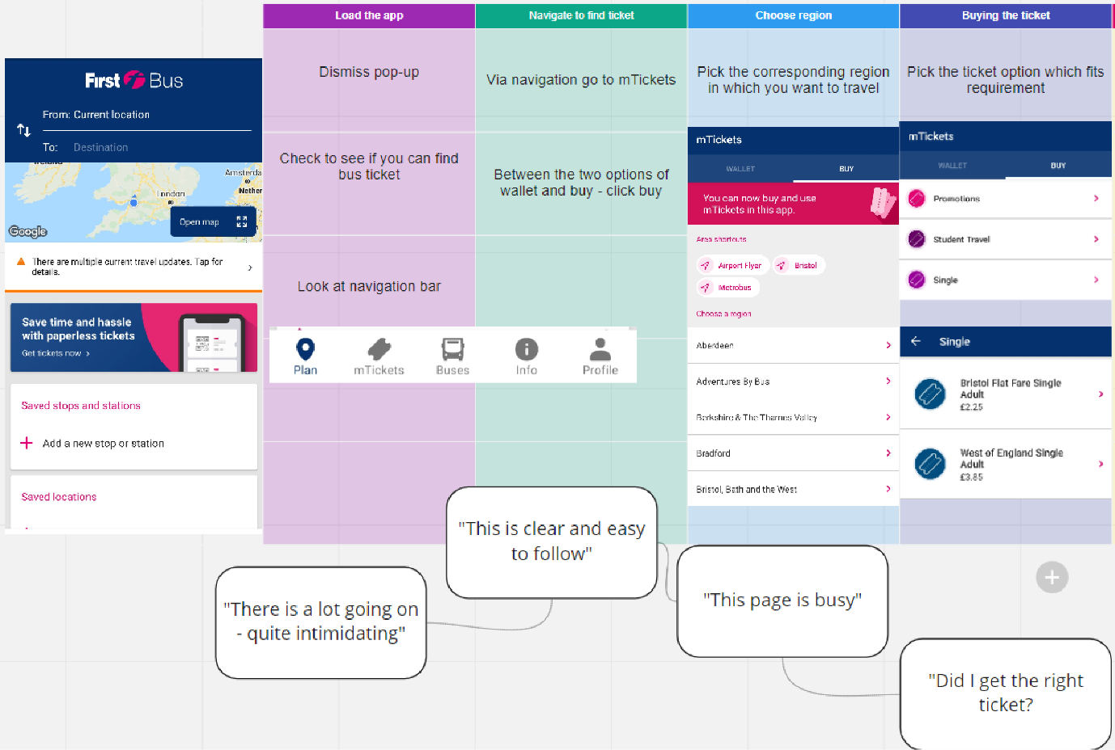

User journey for buying a ticket

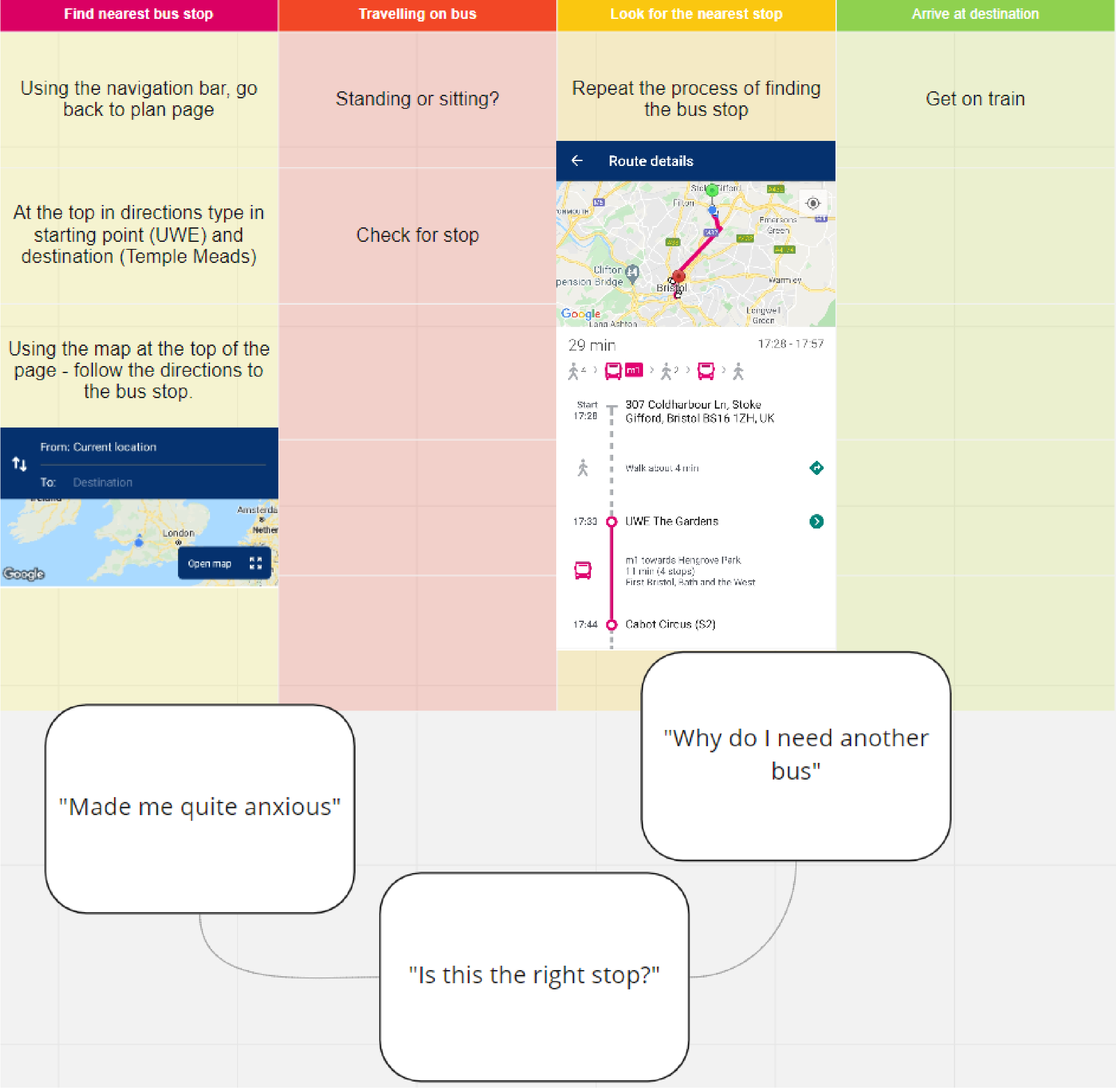

User journey for travelling using first bus app

**Design critiques and recommendations**

The app achieves the bare minimum, it is outdated and needs an update to its layout. The app looks uncared for and lazy – to a customer this is quite off-putting. This is significant as the customer will generalise the apps poor outdated condition with the service. Furthermore, slow response time with the map can cause frustration. For an old, retired person who may already struggle with technology, this is a detriment to their experience. In addition to this, meek colours like grey, can be quite boring or depressing to the user’s eye, the grey background could imply to the audience that first bus is quite a worn-down service. This experience could be changed with a lighter shade of grey or possibly a light blue to fit the colour scheme.

Imagery used on the app is rather poor and sometimes unclear. For example, on the info page under ‘customer service’ is an image of a clock captioned “bus time display”. At first glance it is unclear what the image is, and it could easily be mistaken for something else such as a tick. This is also a problem seen on the navigation bar, the word ‘plan’ can be interpreted in multiple ways and may not be clear to users. Additionally, the image does not do an adequate job of anchoring or possibly implying what the caption means and vice versa.

Moreover, information on the app is rather scattered and customers could end up lost or confused navigating for information. While images are there to ease the experience, as mentioned before; a significant proportion of images are of poor quality or do very little to help guide a user. The consequence of this, would be users leaving bad reviews on the store or giving up with the app entirely. In the case of an old, retired person this could leave them stressed or perhaps feeling helpless after not having clear instructions to find the information they seek.

However, there are some positive aspects. The consistent column design suggests to a user that this is a scrolling app which is good design as it advices the user to scroll and they may find the information they are looking for. Furthermore, a consistent colour scheme throughout the app can make a user feel more comfortable in using the app, especially when there is a minimal number of colours. Additionally, a consistent colour scheme stays in the mind, for example the McDonalds colour scheme of yellow and red is recognisable at a glance. This is significant as a user may be reminded of first bus when they come to think of bus services.

An example of a good page optimised for mobile use is the profile page. It has a very simple layout with ample breaks in between each section a modern interface with the ‘map of services near you’. Furthermore, in between each break is a small body of text describing the function of each section. This is important as the idea of a profile is a rather modern idea and to many is quite self-explanatory, however, to an old, retired person they could find the description helpful and informative.

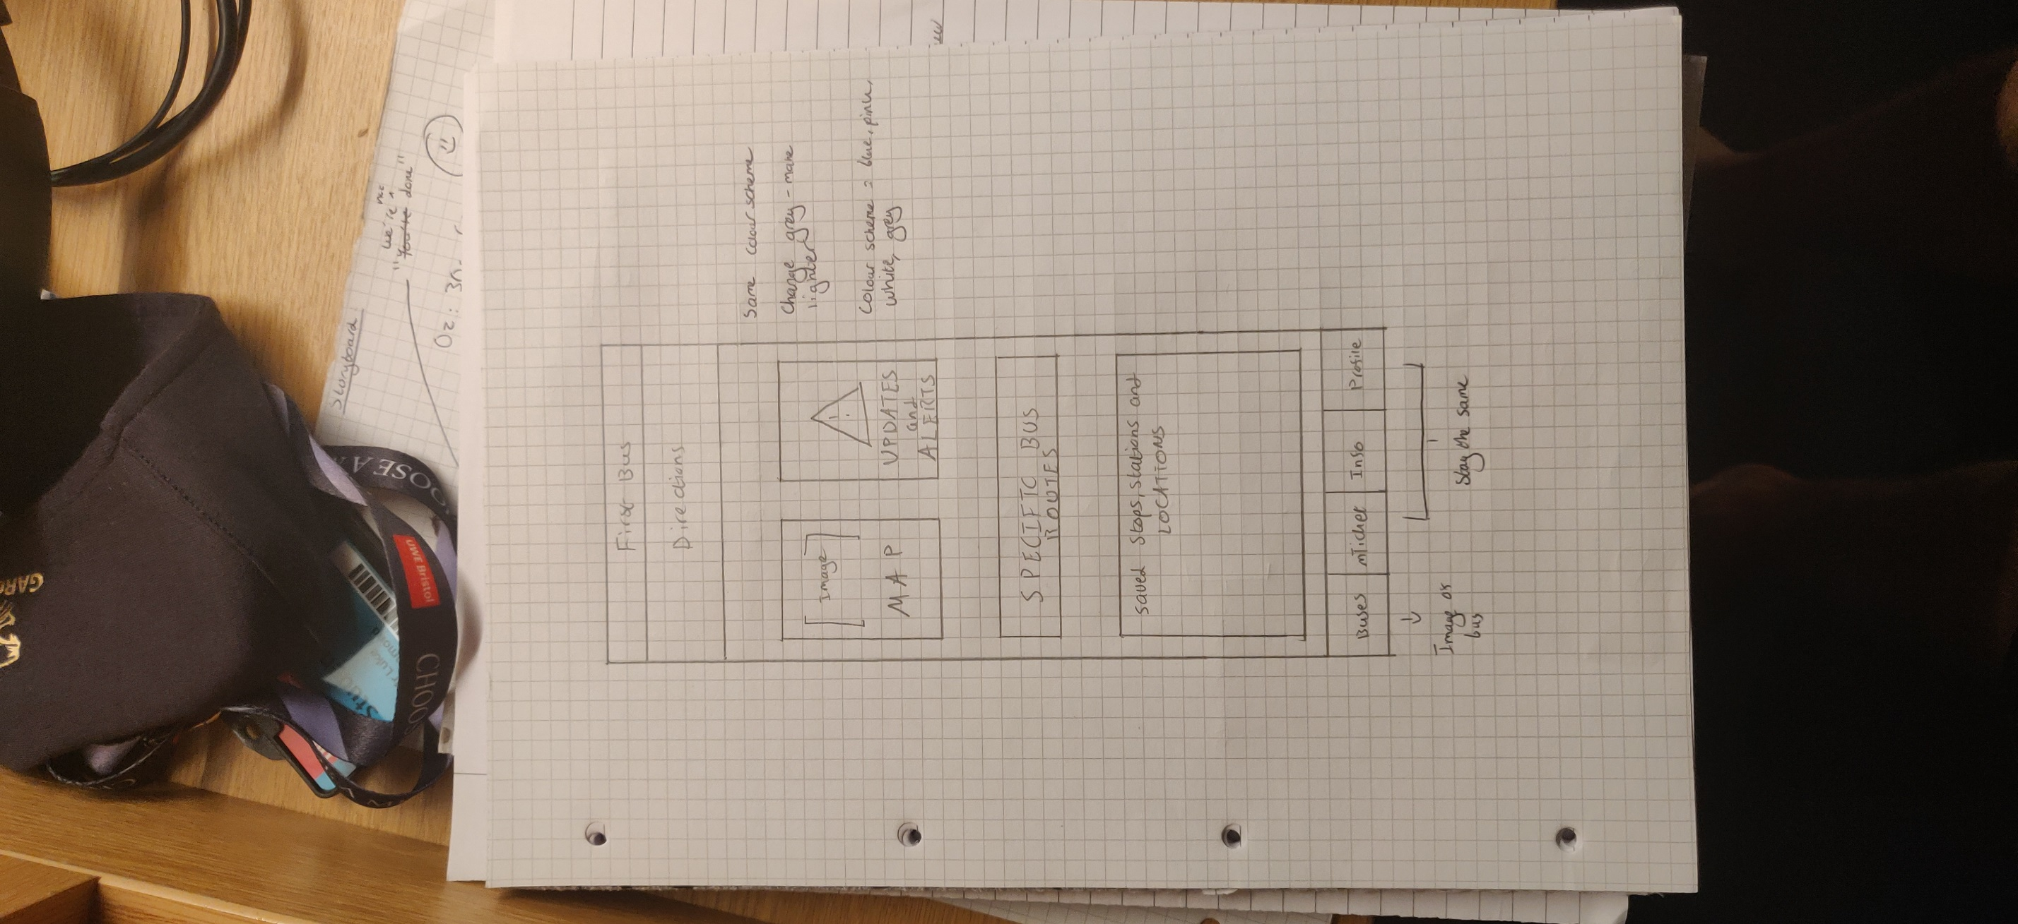

Front page re-design on paper

**Re-Design concept**

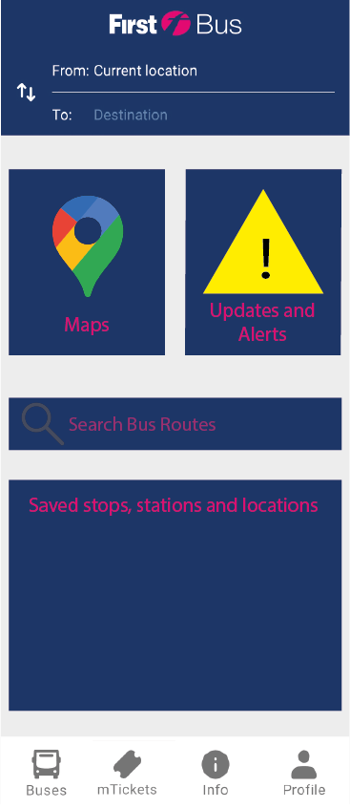

Kept the header of the app the same as it was one function that didn’t need changing.



Colour scheme has been kept the same with the blue and pink. I made the grey a lighter colour, so it is more appealing to the eye and less depressing. The blue could potentially be made a lighter shade as well. Although, this shade of blue is first buses signature blue.



Increased the breaks in between each section so it has a clearer layout. Furthermore, sections have been rescaled, for example updates and alerts can now be seen easily and the maps will be an external link to google maps for a more responsive map.



I combined the plan page with the bus page so now the ‘search bus routes’ is a segment on the first page. This enables similar information to be on one page meaning information is less scattered as well as there being one less page.



aa



Combined saved stops and stations with saved locations as they have a similar function, and it would be easier and easier to understand if they were together rather than separate.

Navigation bar has been decreased to four tabs instead of the five. The ‘plan’ page and ‘buses’ page has been combined and is simply called buses. This is more straightforward and will cause little confusion in comparison to two similar implying titles such as ‘plan’ and ‘buses’.



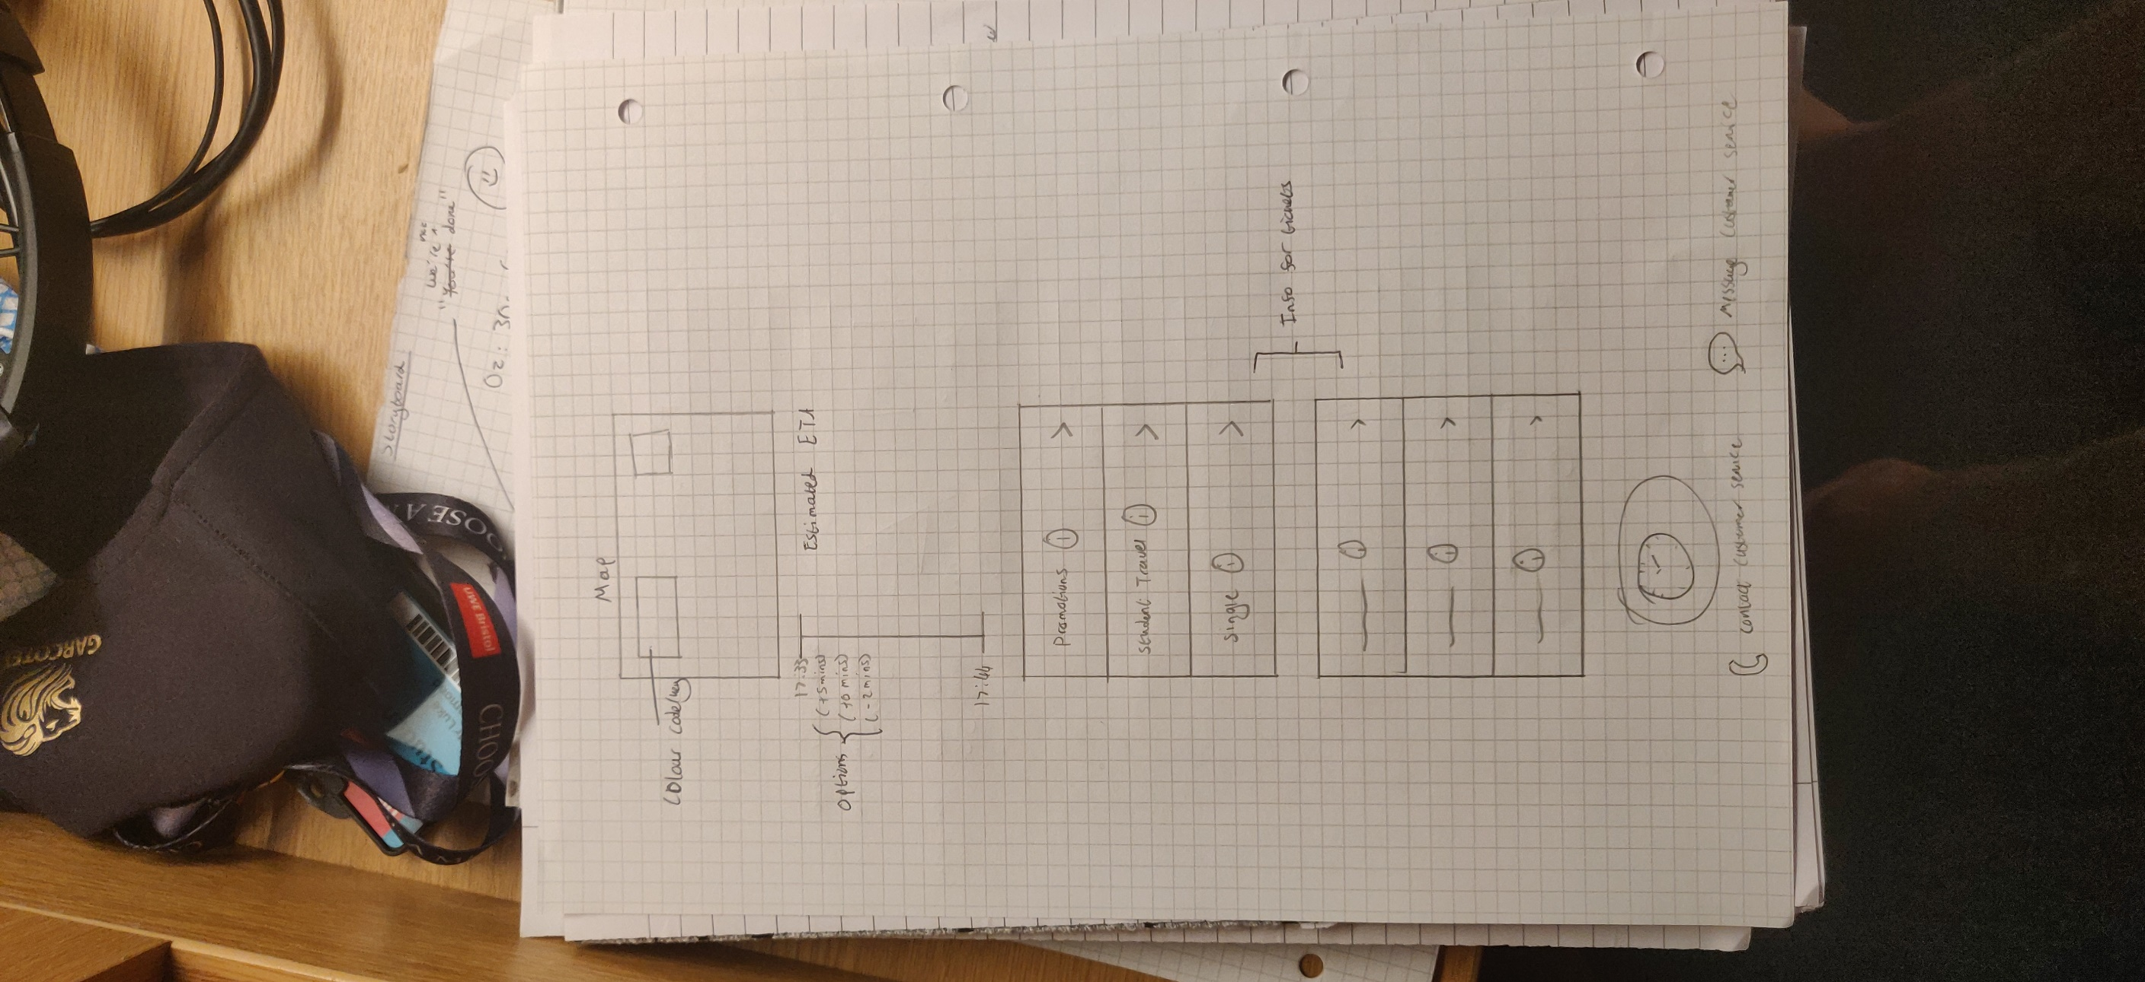

Other re-designs on paper

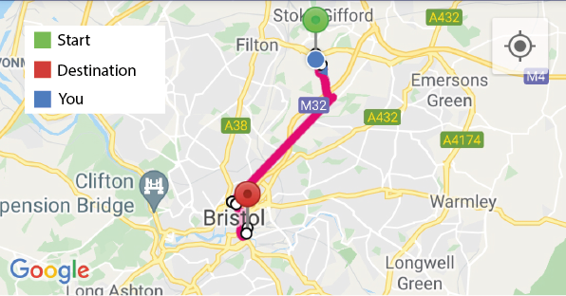

A colour key helps people identify what each colour represents. This can be very useful on a map which may be unclear to many, especially when it is as compressed as it is. The significance of a colour key is that it would be very hard to get confused with where you should go. The only possible fallback is that it doesn’t consider those who are colour blind. This could be made more effective by changing the shape of each icon.



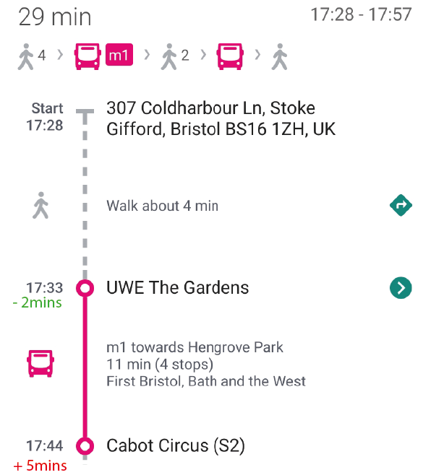



Once again, a colour coded system but this time it informs people of live bus times and possible early or late buses. This idea is very simple but has a lot of value. It can help people plan their journeys better and let others around them be more informed of their actions and ETA.

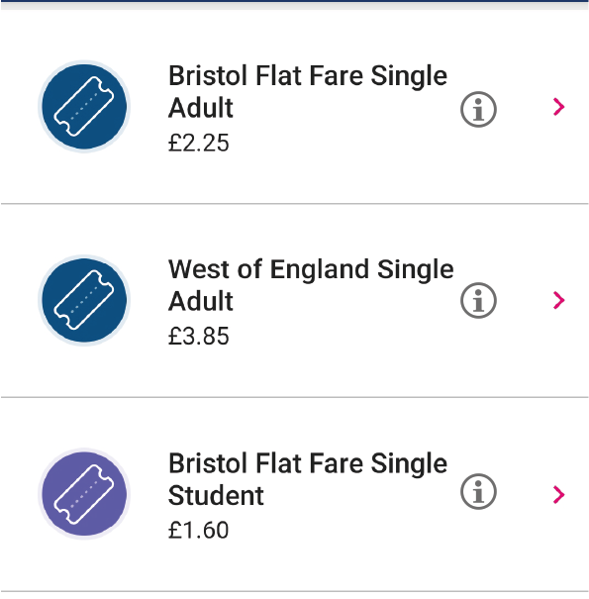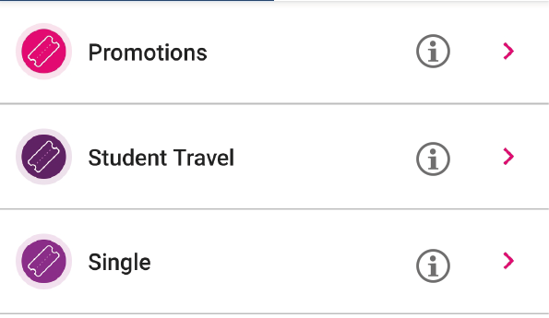



Info next to each ticket can help people understand the specifics of each ticket and whether they are eligible for certain tickets. This will be significant to an old, retired person as they most likely qualify for many discounts they would otherwise not find because of the confusing titles of each ticket.